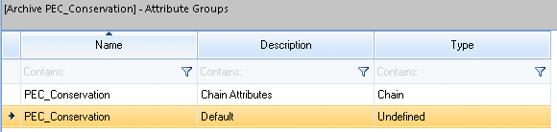

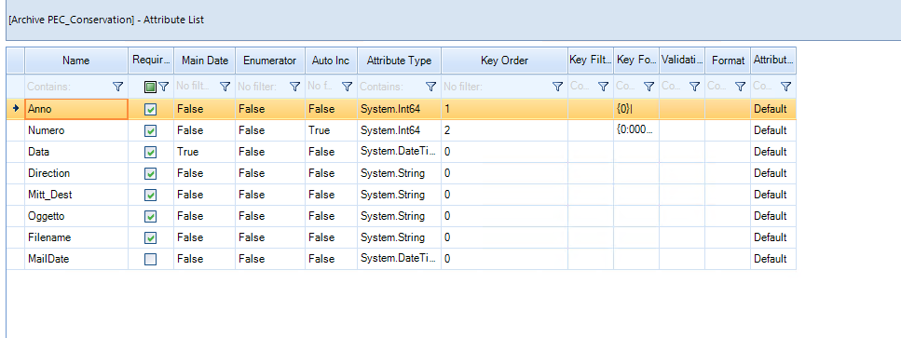

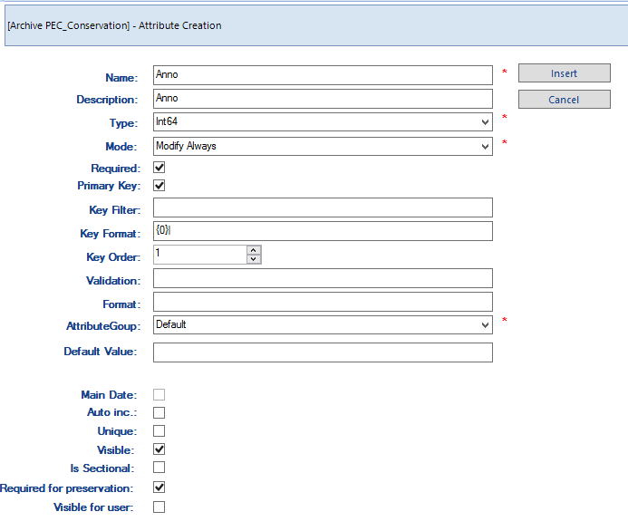

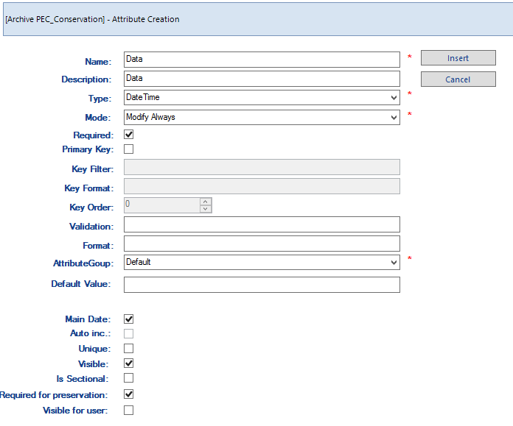

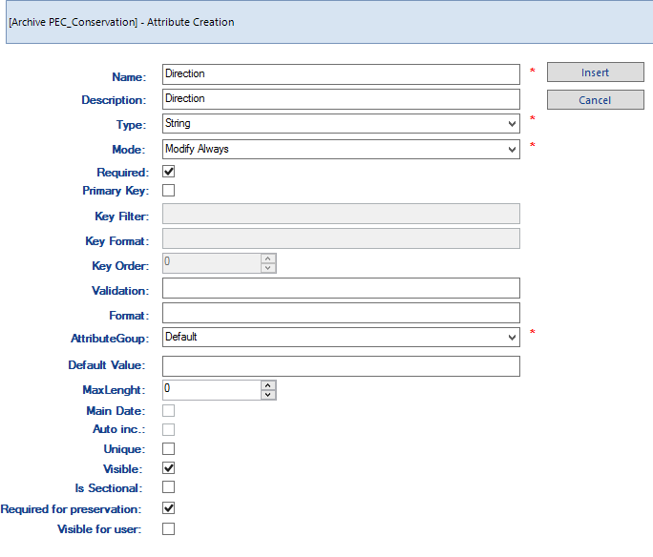

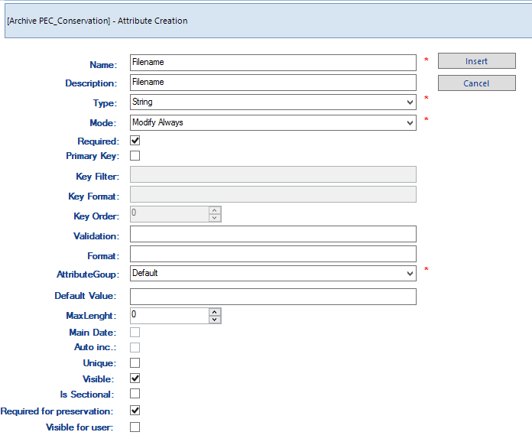

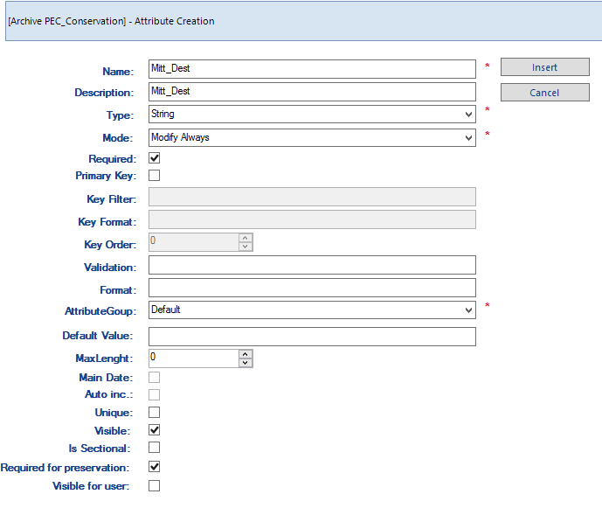

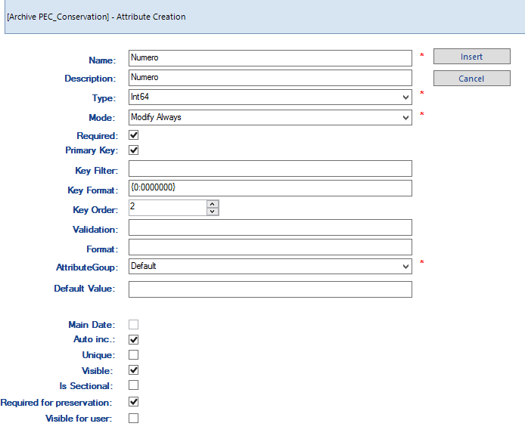

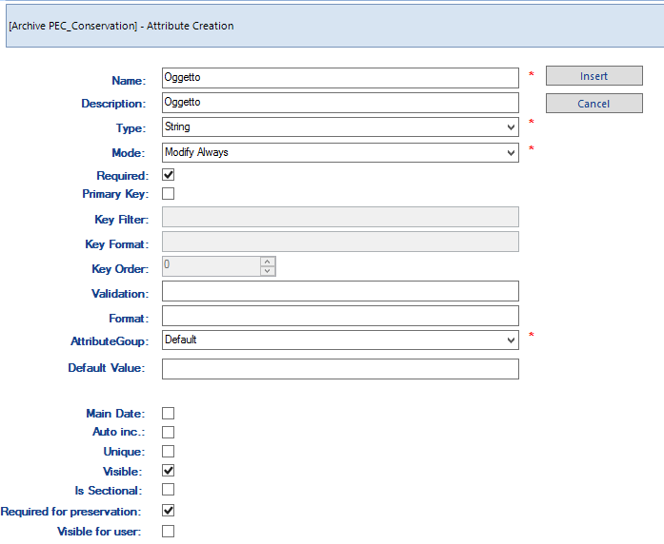

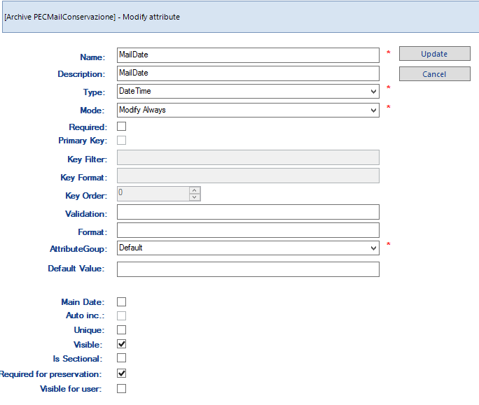

SELECT SU TUTTI I CAMPI order by Name

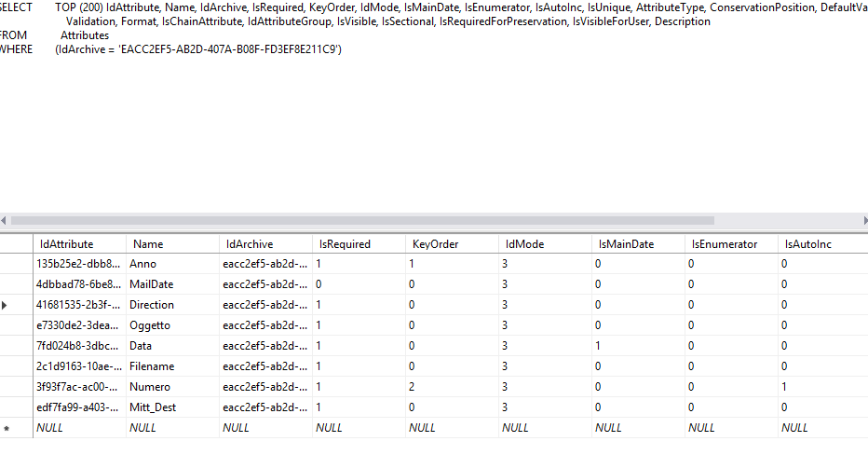

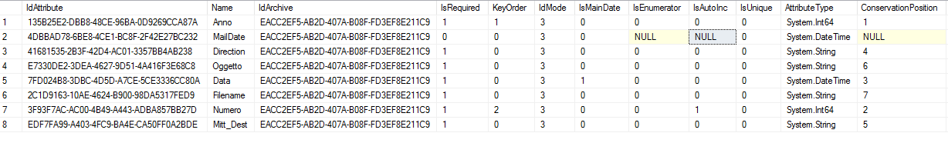

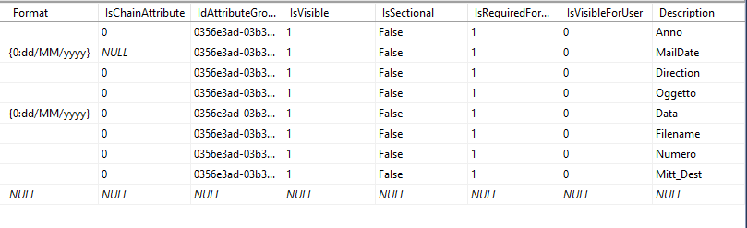

SELECT TOP (200) IdAttribute, Name, IdArchive, IsRequired, KeyOrder, IdMode, IsMainDate, IsEnumerator, IsAutoInc, IsUnique, AttributeType, ConservationPosition,

DefaultValue, MaxLenght, KeyFilter, KeyFormat, Validation, Format, IsChainAttribute, IdAttributeGroup, IsVisible, IsSectional, IsRequiredForPreservation,

IsVisibleForUser, Description

FROM Attributes

WHERE (IdArchive = ‘EACC2EF5-AB2D-407A-B08F-FD3EF8E211C9’)

ORDER BY Name

d2c1c668-512b-4ee2-9edc-5a09934c6926 Anno EACC2EF5-AB2D-407A-B08F-FD3EF8E211C9 1 1 0 0 NULL NULL 0 System.Int64 1 0 {0}| NULL fd0e2b11-dda6-432f-ad6c-a41321728f18 1 False 1 0 Anno

98fcf408-030d-4500-97d9-f892319ddcb4 Data EACC2EF5-AB2D-407A-B08F-FD3EF8E211C9 1 0 0 1 NULL NULL 0 System.DateTime 3 0 NULL fd0e2b11-dda6-432f-ad6c-a41321728f18 1 False 1 0 Data

49031463-3a4b-411b-b33c-02078f5d9412 Direction EACC2EF5-AB2D-407A-B08F-FD3EF8E211C9 1 0 0 0 NULL NULL 0 System.String 4 0 NULL fd0e2b11-dda6-432f-ad6c-a41321728f18 1 False 1 0 Direction

2fa3f2fb-af02-4f30-aad2-fa95685a5026 Filename EACC2EF5-AB2D-407A-B08F-FD3EF8E211C9 0 0 0 0 NULL NULL 0 System.String 7 0 NULL 42d174bc-e4cd-4ae0-9820-eb6a0b847f29 1 False 1 0 Filename

8154b89e-a67e-47f7-ab6c-c8beae219a83 Mitt_Dest a EACC2EF5-AB2D-407A-B08F-FD3EF8E211C9 1 0 0 0 NULL NULL 0 System.String 5 0 NULL fd0e2b11-dda6-432f-ad6c-a41321728f18 1 False 1 0 Mitt_Dest

ccad0841-28b1-413d-8102-9430b8926d9d Numero EACC2EF5-AB2D-407A-B08F-FD3EF8E211C9 1 2 0 0 NULL NULL 0 System.Int64 2 0 {0:0000000} NULL fd0e2b11-dda6-432f-ad6c-a41321728f18 1 False 1 0 Numero

4d7166f1-85ea-4817-aaed-921b524eb023 Oggetto EACC2EF5-AB2D-407A-B08F-FD3EF8E211C9 1 0 0 0 NULL NULL 0 System.String 6 0 NULL fd0e2b11-dda6-432f-ad6c-a41321728f18 1 False 1 0 Oggetto

4dbbad78-6be8-4ce1-bc8f-2f42e27bc232 MailDate eacc2ef5-ab2d-407a-b08f-fd3ef8e211c9 1 0 3 0 0 0 0 System.DateTime 8 NULL 0 0356e3ad-03b3-409e-98d3-031dbb6c454b 1 False 1 0 MailDate

SELECT SUI CAMPI PRINCIPALI order by ConservationPosition

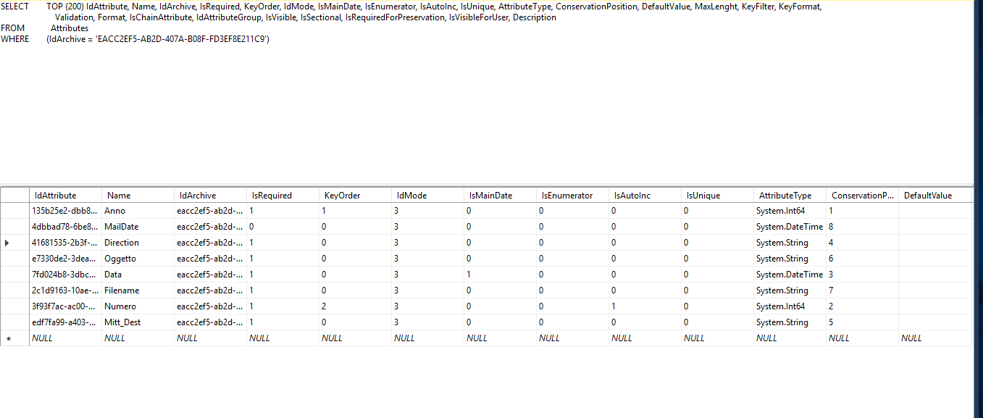

SELECT TOP (200) Name, IsRequired, KeyOrder, IdMode, IsMainDate, AttributeType, ConservationPosition, KeyFormat, IsRequiredForPreservation, IsVisibleForUser,

Description

FROM Attributes

WHERE (IdArchive = 'af08bd69-dc9e-48f8-9420-d139bcf80d27')

ORDER BY ConservationPosition

Anno 1 1 0 0 System.Int64 1 {0}| 1 0 Anno

Numero 1 2 0 0 System.Int64 2 {0:0000000} 1 0 Numero

Data 1 0 0 1 System.DateTime 3 1 0 Data

Direction 1 0 0 0 System.String 4 1 0 Direction

Mitt_Dest 1 0 0 0 System.String 5 1 0 Mitt_Dest

Oggetto 1 0 0 0 System.String 6 1 0 Oggetto

Filename 0 0 0 0 System.String 7 1 0 Filename

MailDate 0 0 3 0 System.DateTime 8 1 0 MailDate

SELECT FROM ARCHIVE

SELECT TOP (200) IdArchive, Name, IsLegal, MaxCache, UpperCache, LowerCache, LastIdBiblos, AutoVersion, AuthorizationAssembly, AuthorizationClassName,

EnableSecurity, PathTransito, PathCache, PathPreservation, LastAutoIncValue, ThumbnailEnabled, PdfConversionEnabled, FullSignEnabled,

VerifyPreservationDateEnabled, VerifyPreservationIncrementalEnabled, TransitoEnabled, FiscalDocumentType, ODBCConnection

FROM Archive

WHERE (IdArchive = 'af08bd69-dc9e-48f8-9420-d139bcf80d27')

af08bd69-dc9e-48f8-9420-d139bcf80d27 PEC_Conservation 1 1073741824 805306368 536870912 0 NULL NULL NULL 0 D:\BiblosDS2010\Transito\PEC_Conservation NULL D:\Preservation\ASL-TO2 NULL False NULL True True False NULL ASLTO2_Pec NULL

ARCHIVE.TemplateCloseFile

File di chiusura dei documenti elencati nel percorso: <%PERCORSO%>

Nome File Indice: <%FILE_INDICE%>

Generato il <%DATA_ORA%>

Tipo evidenza informatica: <%EVIDENZA_INFORMATICA%>

Evidenza informatica file indice (formato Hex): <%EVIDENZA_INDICE_TXT%>

Evidenza informatica file indice XML (formato Hex): <%EVIDENZA_INDICE_XML%>

Evidenza informatica foglio di stile di visualizzazione (formato Hex): <%EVIDENZA_INDICE_XSL%>

Riferimento Azienda:<%AZIENDA%> P.IVA <%PIVA_AZIENDA%>

Responsabile Procedimento Conservazione: <%RESPONSABILE%>

Nome Archivio: <%ARCHIVIO%>

Tipo Documenti: <%TIPO_DOCUMENTI%>

Numero Documenti: <%NUMERO_DOCUMENTI%>

Data Primo Documento: <%DATA_PRIMO_DOCUMENTO%>

Data Ultimo Documento: <%DATA_ULTIMO_DOCUMENTO%>

Identificativo Conservazione Sostitutiva: <%ID_CONSERVAZIONE%>

Il file indice esplicita i seguenti campi:

<%ELENCO_CAMPI%>

ARCHIVECOMPANY.TemplateXSLTFile

<?xml version="1.0" encoding="ISO-8859-1"?>

<xsl:stylesheet version="2.0" xmlns:xsl="http://www.w3.org/1999/XSL/Transform">

<xsl:template match="/">

<html>

<head>

<title>Lista</title>

</head>

<body>

<table style="width:100%;font-family:Verdana;font-size:small;" cellpadding="4">

<tr style="font-weight:bold;background-color:#aaaaaa">

<td>Progressivo</td>

<td>Anno</td>

<td>Numero</td>

<td>Data</td>

<td>Direzione</td>

<td>Mitt_Dest</td>

<td>Oggetto</td>

<td>MailDate</td>

<td>NomeFileInArchivio</td>

<td>ImprontaFileSHA256</td>

</tr>

<xsl:for-each select="Indice/File">

<tr>

<xsl:if test="(position() mod 2 = 1)">

<xsl:attribute name="style">background-color:#eeeeee</xsl:attribute>

</xsl:if>

<td>

<xsl:value-of select="@Progressivo" />

</td>

<td>

<xsl:choose>

<xsl:when test="count(Attributo[@Nome='Anno']/child::node()) = 1">

<xsl:value-of select="Attributo[@Nome='Anno']" />

</xsl:when>

<xsl:otherwise>

<xsl:text disable-output-escaping="yes">&amp;nbsp;</xsl:text>

</xsl:otherwise>

</xsl:choose>

</td>

<td>

<xsl:choose>

<xsl:when test="count(Attributo[@Nome='Numero']/child::node()) = 1">

<xsl:value-of select="Attributo[@Nome='Numero']" />

</xsl:when>

<xsl:otherwise>

<xsl:text disable-output-escaping="yes">&amp;nbsp;</xsl:text>

</xsl:otherwise>

</xsl:choose>

</td>

<td>

<xsl:choose>

<xsl:when test="count(Attributo[@Nome='Data']/child::node()) = 1">

<xsl:value-of select="Attributo[@Nome='Data']" />

</xsl:when>

<xsl:otherwise>

<xsl:text disable-output-escaping="yes">&amp;nbsp;</xsl:text>

</xsl:otherwise>

</xsl:choose>

</td>

<td>

<xsl:choose>

<xsl:when test="count(Attributo[@Nome='Direzione']/child::node()) = 1">

<xsl:value-of select="Attributo[@Nome='Direzione']" />

</xsl:when>

<xsl:otherwise>

<xsl:text disable-output-escaping="yes">&amp;nbsp;</xsl:text>

</xsl:otherwise>

</xsl:choose>

</td>

<td>

<xsl:choose>

<xsl:when test="count(Attributo[@Nome='Mitt_Dest']/child::node()) = 1">

<xsl:value-of select="Attributo[@Nome='Mitt_Dest']" />

</xsl:when>

<xsl:otherwise>

<xsl:text disable-output-escaping="yes">&amp;nbsp;</xsl:text>

</xsl:otherwise>

</xsl:choose>

</td>

<td>

<xsl:choose>

<xsl:when test="count(Attributo[@Nome='Oggetto']/child::node()) = 1">

<xsl:value-of select="Attributo[@Nome='Oggetto']" />

</xsl:when>

<xsl:otherwise>

<xsl:text disable-output-escaping="yes">&amp;nbsp;</xsl:text>

</xsl:otherwise>

</xsl:choose>

</td>

<td>

<xsl:choose>

<xsl:when test="count(Attributo[@Nome='MailDate']/child::node()) = 1">

<xsl:value-of select="Attributo[@Nome='MailDate']" />

</xsl:when>

<xsl:otherwise>

<xsl:text disable-output-escaping="yes">&amp;nbsp;</xsl:text>

</xsl:otherwise>

</xsl:choose>

</td>

<td>

<a>

<xsl:attribute name="target">_blank</xsl:attribute>

<xsl:attribute name="href">

<xsl:value-of select="Attributo[@Nome='NomeFileInArchivio']" />

</xsl:attribute>

<xsl:value-of select="Attributo[@Nome='NomeFileInArchivio']" />

</a>

</td>

<td>

<xsl:choose>

<xsl:when test="count(Attributo[@Nome='ImprontaFileSHA256']/child::node()) = 1">

<xsl:value-of select="Attributo[@Nome='ImprontaFileSHA256']" />

</xsl:when>

<xsl:otherwise>

<xsl:text disable-output-escaping="yes">&amp;nbsp;</xsl:text>

</xsl:otherwise>

</xsl:choose>

</td>

</tr>

</xsl:for-each>

</table>

</body>

</html>

</xsl:template>

</xsl:stylesheet>